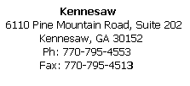
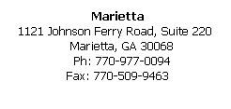

Request for Release of Records

To: Doctor or Practice Name:__________________________________________________________________

Street Address:_____________________________________________________________________________

City:_________________________________________State:___________Zip Code:_____________________

Fax Number:_____________________________________ Phone:____________________________________

Please send copies of my child’s/children’s complete medical records to the following address:

East Cobb Pediatrics and Adolescent Medicine
6110 Pine Mountain Road
Suite 202
Kennesaw, Georgia 30152
770-795-4553
Fax: 770-795-4513

Child’s Name:_________________________________________________ DOB________________________

Child’s Name:__________________________________________________DOB________________________

Child’s Name:__________________________________________________DOB________________________

Address:__________________________________________________________________________________

Parent Name_________________________________________ Phone Number:_________________________

Signature of Parent or Guardian:_______________________________________________________________

Date:______________________

This authorization is valid one year from date signed.

